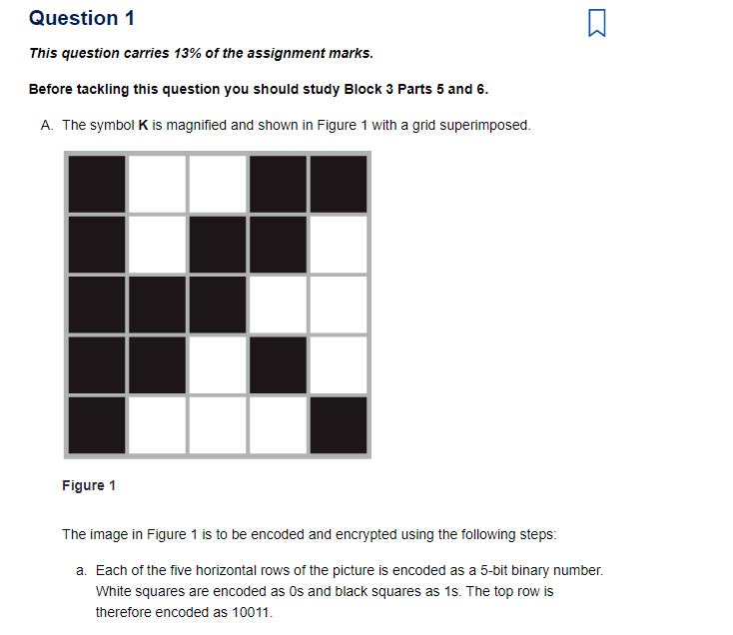
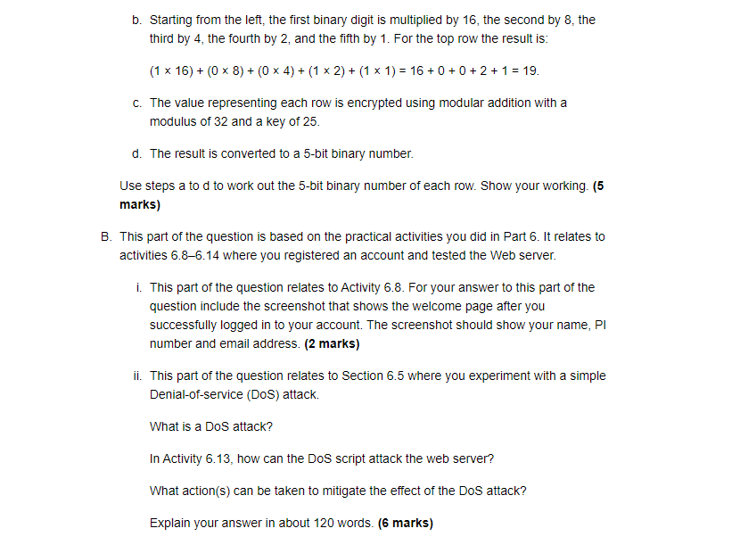

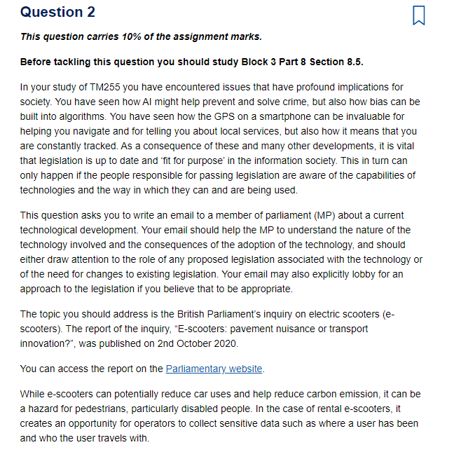

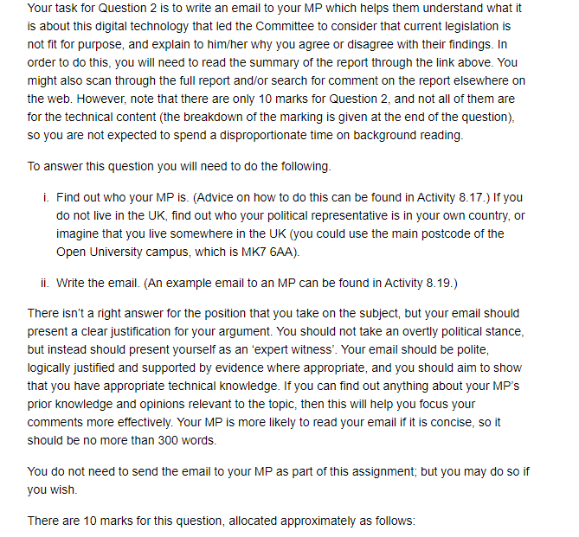

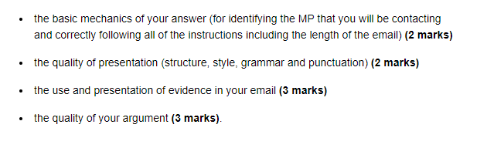

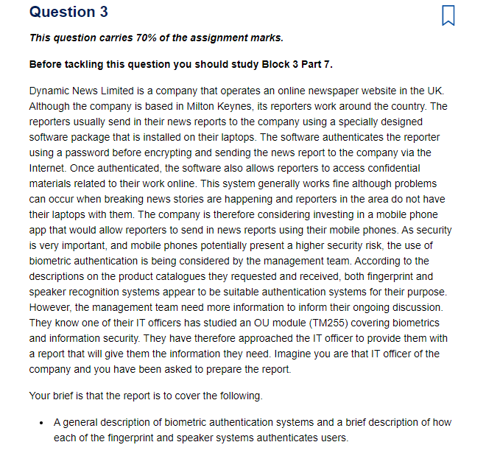

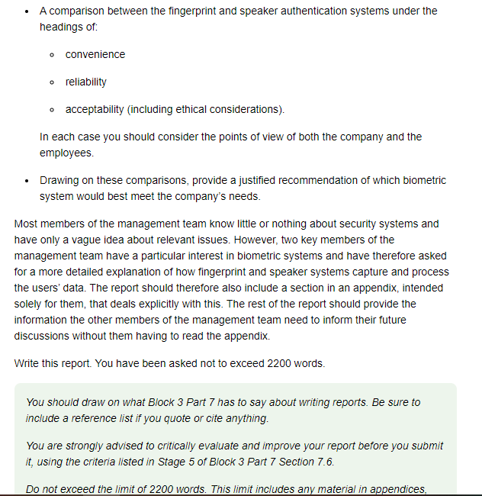
but does not include the executive summary, which will be your answer to Question 4. State the total number of words you have used at the end of your report.
See also ‘Notes relating to Question 3’ near the end of this TMA.

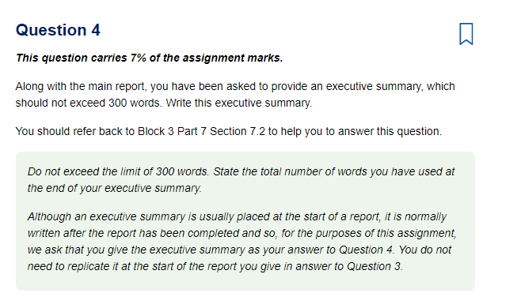

Notes relating to Question 3
In this question you need to ‘role play’ – that is, you need to write a report that not only meets the brief but also suits the specified audience and purpose.

Material beyond TM255
Most of the material you need in order to write the report is contained in Block 3. For speaker recognition systems, which are not covered by the block material in great depth, the TM255 module team suggests you use the following papers. Although the papers are not recent, the technologies are fairly stable. You should be aware that the papers were written to promote their own biometric technologies, so their points of view may be biased.
- National Cyber Security Centre (2019) Biometric recognition and authentication systems [Online]. Available at https://www.ncsc.gov.uk/ collection/ biometrics/ speaker-recognition (Accessed 25 September 2020).
- Reynolds, D. (2002) ‘An overview of automatic speaker recognition technology’, IEEE International Conference on Acoustics, Speech, and Signal Processing, vol. 4, pp. 4072–4075 [Online]. Available at http://ieeexplore.ieee.org.libezproxy.open.ac.uk/ stamp/ stamp.jsp?tp=&arnumber=5745552 (Accessed 25 September 2020).
You may need to do a little research on the web in order to expand your understanding of one or two topics, but you should not need to spend more than an absolute maximum of an hour doing this.

Counting the number of words used
Your total of the number of words you have used in Question 3 should include:
- all headings – including sub-headings, table headings and figure captions
- any material you put in appendices
- any glossary
- any items you put in lists – except a reference list
- any footnotes
- any quotations you make from other sources.
You may exclude:
- the contents list (if any)
- the bibliography (if any)
- the reference list
- text within figures
- text within tables.
Please note, however, that if you have put text into a table simply to reduce the word count, rather than because a table is the most appropriate means of presenting the information, your tutor will adjust your word total upwards by an appropriate amount.

